Litter inventory form

Breeder
Name click or tap to insert breeder’s name
City click or tap to insert breeder’s city
State click or tap to insert breeder’s state

Kennelname:
Name click or tap to insert kennelname
Prefix or Suffix choose an item

Litter:
Date of birth litter click or tap to insert date of birth

The bitch gave birth to choose number males and choose number bitches

How many pups died? choose number males and choose number bitches

If so, what was the cause? click or tap to insert cause of death

Autopsy? choose an item
Autopsy report? choose an item

Father of the litter:
Name click or tap to insert father’s name
Pedigreenumber choose studbook
click or tap to insert father’s pedigreenumber

From combination: Sire (name) click or tap to insert name sire
Dam(name) click or tap to insert name dam

Mother of the litter:
Name click or tap to insert mother’s name

Pedigreenumber choose studbook
click or tap to insert mother’s pedigreenumber

From combination: Sire (name) click or tap to insert name sire
Dam (name) click or tap to insert name dam

Example of the photo’s of the pup to be inserted:

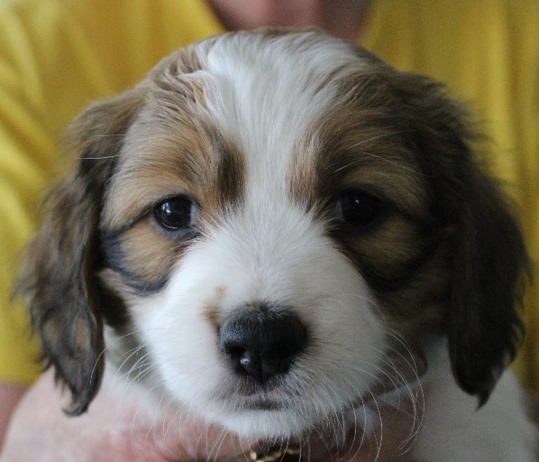 |  | 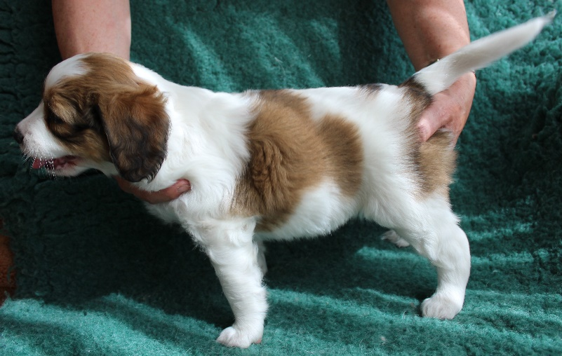
head |  | left side
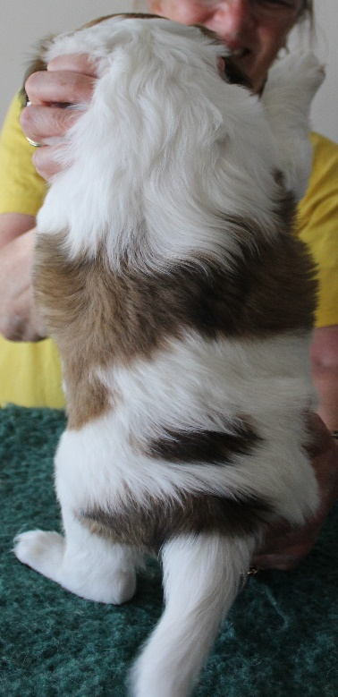 |  | 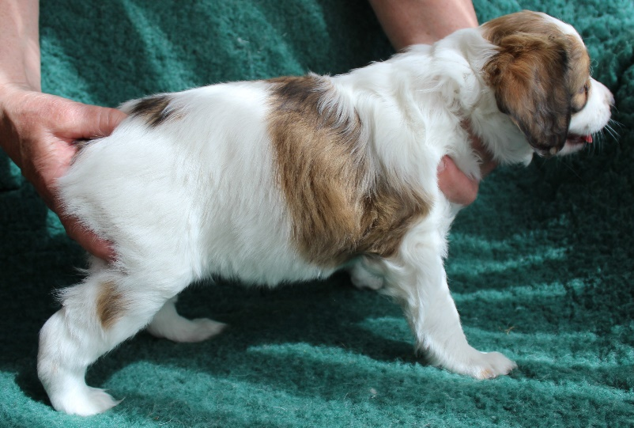
 |  | right side
above

To limit the file size please use compressed photo’s or do the following after inputting the photo’s:
- Click on one of the photo’s to open the menu ‘picture tools / picture format’ 
- In the menu tools for images choose for ‘compress pictures’
- Set resolution to 220 ppi and save the changes


Name pup 1 click or tap to insert pup’s name
Gender choose an item
Pedigreenumber choose studbook
click or tap to insert pedigreenumber
Chipnumber click or tap to insert chipnumber
Colour choose an item additional explanation
Marking body choose an item additional explanation
Marking head choose an item
Head choose an item
Stop choose an item
Bite choose an item additional explanation
Eyes colour choose an item additional explanation
Eyes shape choose an item additional explanation
Ears ☐ well placed ☐ set low ☐ good length ☐ shorter ears
Bone choose an item
Tail choose an item additional explanation
Male two testickels choose an item
Remarks click or tap to insert remarks



Name pup 2 click or tap to insert pup’s name
Gender choose an item
Pedigreenumber choose studbook
click or tap to insert pedigreenumber
Chipnumber click or tap to insert chipnumber
Colour choose an item additional explanation
Marking body choose an item additional explanation
Marking head choose an item
Head choose an item
Stop choose an item
Bite choose an item additional explanation
Eyes colour choose an item additional explanation
Eyes shape choose an item additional explanation
Ears ☐ well placed ☐ set low ☐ good length ☐ shorter ears
Bone choose an item
Tail choose an item additional explanation
Male two testickels choose an item
Remarks click or tap to insert remarks

Name pup 3 click or tap to insert pup’s name
Gender choose an item
Pedigreenumber choose studbook
click or tap to insert pedigreenumber
Chipnumber click or tap to insert chipnumber
Colour choose an item additional explanation
Marking body choose an item additional explanation
Marking head choose an item
Head choose an item
Stop choose an item
Bite choose an item additional explanation
Eyes colour choose an item additional explanation
Eyes shape choose an item additional explanation
Ears ☐ well placed ☐ set low ☐ good length ☐ shorter ears
Bone choose an item
Tail choose an item additional explanation
Male two testickels choose an item
Remarks click or tap to insert remarks

Name pup 4 click or tap to insert pup’s name
Gender choose an item
Pedigreenumber choose studbook
click or tap to insert pedigreenumber
Chipnumber click or tap to insert chipnumber
Colour choose an item additional explanation
Marking body choose an item additional explanation
Marking head choose an item
Head choose an item
Stop choose an item
Bite choose an item additional explanation
Eyes colour choose an item additional explanation
Eyes shape choose an item additional explanation
Ears ☐ well placed ☐ set low ☐ good length ☐ shorter ears
Bone choose an item
Tail choose an item additional explanation
Male two testickels choose an item
Remarks click or tap to insert remarks

Name pup 5 click or tap to insert pup’s name
Gender choose an item
Pedigreenumber choose studbook
click or tap to insert pedigreenumber
Chipnumber click or tap to insert chipnumber
Colour choose an item additional explanation
Marking body choose an item additional explanation
Marking head choose an item
Head choose an item
Stop choose an item
Bite choose an item additional explanation
Eyes colour choose an item additional explanation
Eyes shape choose an item additional explanation
Ears ☐ well placed ☐ set low ☐ good length ☐ shorter ears
Bone choose an item
Tail choose an item additional explanation
Male two testickels choose an item
Remarks click or tap to insert remarks

Name pup 6 click or tap to insert pup’s name
Gender choose an item
Pedigreenumber choose studbook
click or tap to insert pedigreenumber
Chipnumber click or tap to insert chipnumber
Colour choose an item additional explanation
Marking body choose an item additional explanation
Marking head choose an item
Head choose an item
Stop choose an item
Bite choose an item additional explanation
Eyes colour choose an item additional explanation
Eyes shape choose an item additional explanation
Ears ☐ well placed ☐ set low ☐ good length ☐ shorter ears
Bone choose an item
Tail choose an item additional explanation
Male two testickels choose an item
Remarks click or tap to insert remarks

Name pup 7 click or tap to insert pup’s name
Gender choose an item
Pedigreenumber choose studbook
click or tap to insert pedigreenumber
Chipnumber click or tap to insert chipnumber
Colour choose an item additional explanation
Marking body choose an item additional explanation
Marking head choose an item
Head choose an item
Stop choose an item
Bite choose an item additional explanation
Eyes colour choose an item additional explanation
Eyes shape choose an item additional explanation
Ears ☐ well placed ☐ set low ☐ good length ☐ shorter ears
Bone choose an item
Tail choose an item additional explanation
Male two testickels choose an item
Remarks click or tap to insert remarks

Name pup 8 click or tap to insert pup’s name
Gender choose an item
Pedigreenumber choose studbook
click or tap to insert pedigreenumber
Chipnumber click or tap to insert chipnumber
Colour choose an item additional explanation
Marking body choose an item additional explanation
Marking head choose an item
Head choose an item
Stop choose an item
Bite choose an item additional explanation
Eyes colour choose an item additional explanation
Eyes shape choose an item additional explanation
Ears ☐ well placed ☐ set low ☐ good length ☐ shorter ears
Bone choose an item
Tail choose an item additional explanation
Male two testickels choose an item
Remarks click or tap to insert remarks

Name pup 9 click or tap to insert pup’s name
Gender choose an item
Pedigreenumber choose studbook
click or tap to insert pedigreenumber
Chipnumber click or tap to insert chipnumber
Colour choose an item additional explanation
Marking body choose an item additional explanation
Marking head choose an item
Head choose an item
Stop choose an item
Bite choose an item additional explanation
Eyes colour choose an item additional explanation
Eyes shape choose an item additional explanation
Ears ☐ well placed ☐ set low ☐ good length ☐ shorter ears
Bone choose an item
Tail choose an item additional explanation
Male two testickels choose an item
Remarks click or tap to insert remarks

Name pup 10 click or tap to insert pup’s name
Gender choose an item
Pedigreenumber choose studbook
click or tap to insert pedigreenumber
Chipnumber click or tap to insert chipnumber
Colour choose an item additional explanation
Marking body choose an item additional explanation
Marking head choose an item
Head choose an item
Stop choose an item
Bite choose an item additional explanation
Eyes colour choose an item additional explanation
Eyes shape choose an item additional explanation
Ears ☐ well placed ☐ set low ☐ good length ☐ shorter ears
Bone choose an item
Tail choose an item additional explanation
Male two testickels choose an item
Remarks click or tap to insert remarks

Name pup 11 click or tap to insert pup’s name
Gender choose an item
Pedigreenumber choose studbook
click or tap to insert pedigreenumber
Chipnumber click or tap to insert chipnumber
Colour choose an item additional explanation
Marking body choose an item additional explanation
Marking head choose an item
Head choose an item
Stop choose an item
Bite choose an item additional explanation
Eyes colour choose an item additional explanation
Eyes shape choose an item additional explanation
Ears ☐ well placed ☐ set low ☐ good length ☐ shorter ears
Bone choose an item
Tail choose an item additional explanation
Male two testickels choose an item
Remarks click or tap to insert remarks

Name pup 12 click or tap to insert pup’s name
Gender choose an item
Pedigreenumber choose studbook
click or tap to insert pedigreenumber
Chipnumber click or tap to insert chipnumber
Colour choose an item additional explanation
Marking body choose an item additional explanation
Marking head choose an item
Head choose an item
Stop choose an item
Bite choose an item additional explanation
Eyes colour choose an item additional explanation
Eyes shape choose an item additional explanation
Ears ☐ well placed ☐ set low ☐ good length ☐ shorter ears
Bone choose an item
Tail choose an item additional explanation
Male two testickels choose an item
Remarks click or tap to insert remarks

